Mrs. Cooks’ Smart Cookies
Week of April 20-24, 2020
Newsletter & Important Dates
Everyday: | Use your BEST handwriting! Make sure your name is on your homework!  Remember, daily homework is practice that will help you remember what you have learned! Read 20 minutes, record onto Reading Log. Complete all homework and turn in homework book on Friday. Check folder for additional Math or Language Arts worksheets. A homework menu is in your child’s binder.

don’t | won’t | English/Language Arts- Contractions  Math-Data: Using Data from Real Graphs  Social Studies-  Week #19 Work and Wk#20 Money  Science-Brainpopjr. Light and Earth Day Activities (recycling) | 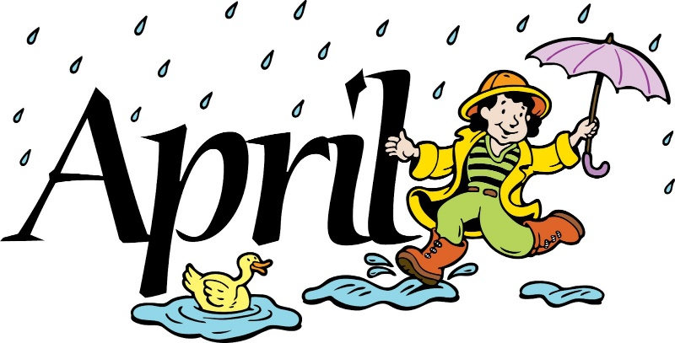  Please have your child practice 20min of reading/math each evening & send in headphones if he or she doesn’t have them    May 8th-last day of assigned lessons  May 22nd- last day to submit lessons
didn’t | wouldn’t
can’t | couldn’t
it’s | isn’t
they’re | shouldn’t
 | Complete Spelling City Lessons  Use Brainpopjr. for math, language arts, science and social studies

